第七組

1112410018 許哲維

1112410027 陳閔詩

1112410037 曾乙珈

1112410039 林雅菁

1112410040 蔡姵涵

1112410045 林胤龍

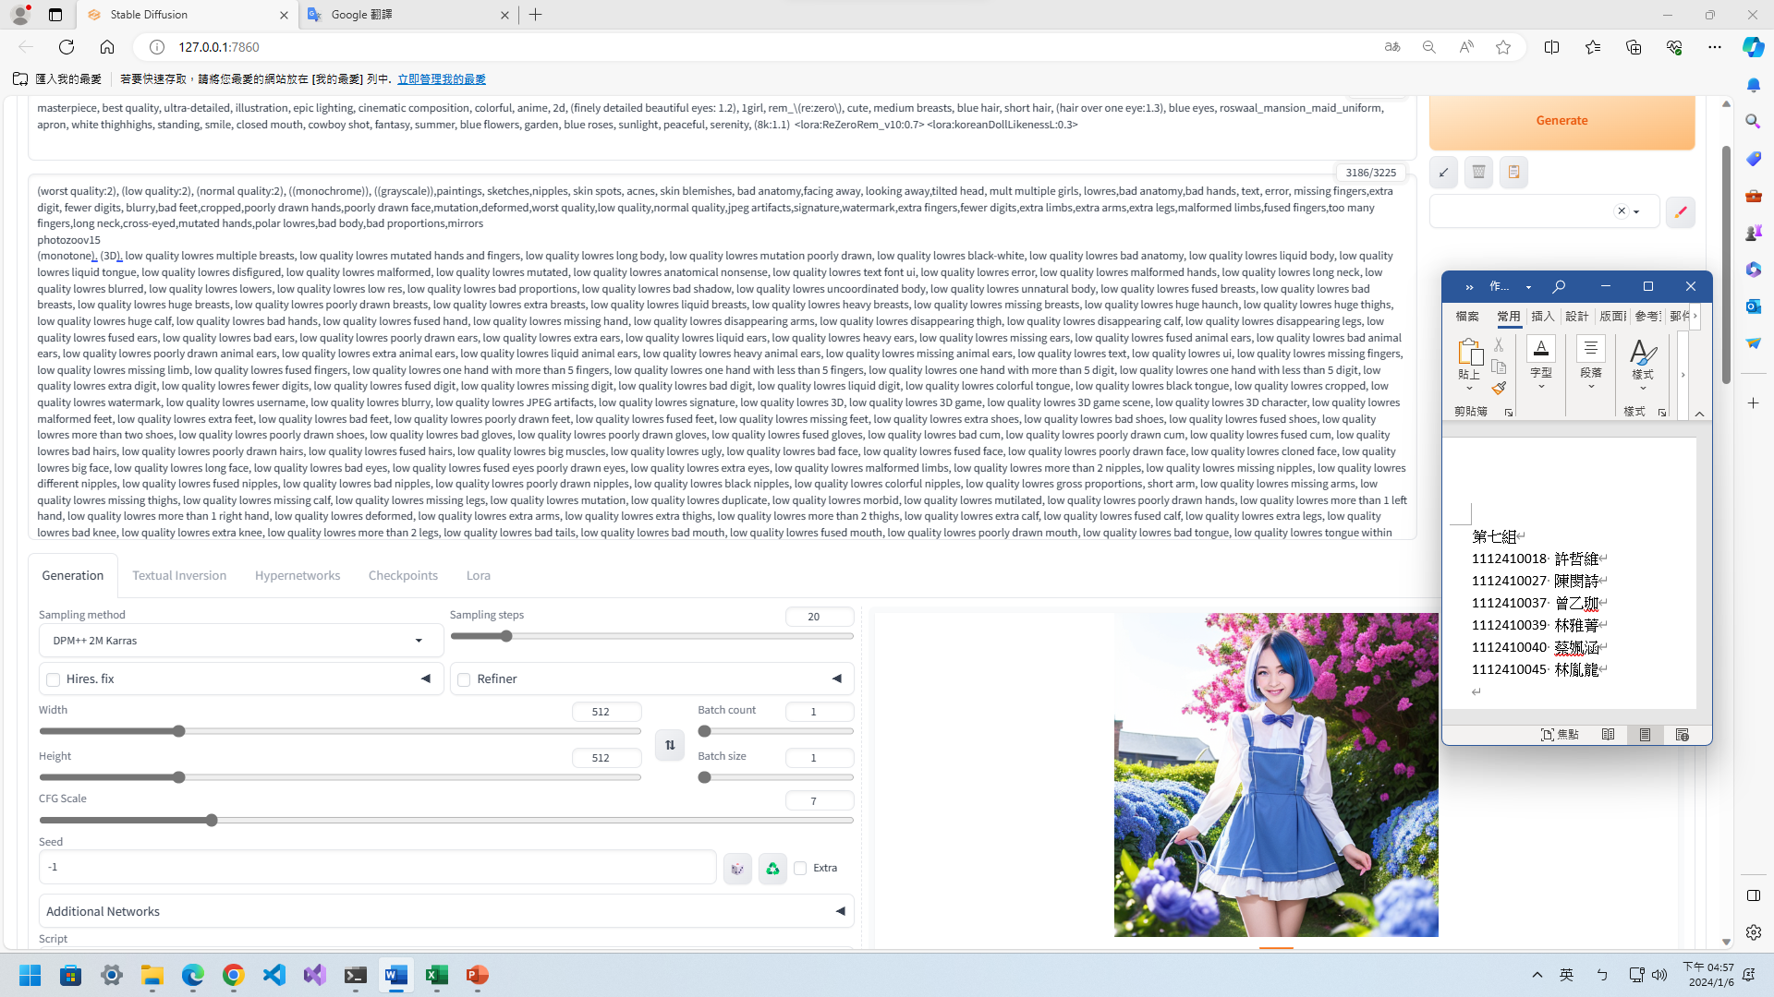

正面:

sterpiece, best quality, ultra-detailed, illustration, epic lighting, cinematic composition, colorful, anime, 2d, (finely detailed beautiful eyes: 1.2), 1girl, rem_\(re:zero\), cute, medium breasts, blue hair, short hair, (hair over one eye:1.3), blue eyes, roswaal_mansion_maid_uniform, apron, white thighhighs, standing, smile, closed mouth, cowboy shot, fantasy, summer, blue flowers, garden, blue roses, sunlight, peaceful, serenity, (8k:1.1) <lora:ReZeroRem_v10:0.7> <lora:koreanDollLikenessL:0.3>

負面:

(worst quality:2), (low quality:2), (normal quality:2), ((monochrome)), ((grayscale)),paintings, sketches,nipples, skin spots, acnes, skin blemishes, bad anatomy,facing away, looking away,tilted head, mult multiple girls, lowres,bad anatomy,bad hands, text, error, missing fingers,extra digit, fewer digits, blurry,bad feet,cropped,poorly drawn hands,poorly drawn face,mutation,deformed,worst quality,low quality,normal quality,jpeg artifacts,signature,watermark,extra fingers,fewer digits,extra limbs,extra arms,extra legs,malformed limbs,fused fingers,too many fingers,long neck,cross-eyed,mutated hands,polar lowres,bad body,bad proportions,mirrors

photozoov15

(monotone). (3D). low quality lowres multiple breasts, low quality lowres mutated hands and fingers, low quality lowres long body, low quality lowres mutation poorly drawn, low quality lowres black-white, low quality lowres bad anatomy, low quality lowres liquid body, low quality lowres liquid tongue, low quality lowres disfigured, low quality lowres malformed, low quality lowres mutated, low quality lowres anatomical nonsense, low quality lowres text font ui, low quality lowres error, low quality lowres malformed hands, low quality lowres long neck, low quality lowres blurred, low quality lowres lowers, low quality lowres low res, low quality lowres bad proportions, low quality lowres bad shadow, low quality lowres uncoordinated body, low quality lowres unnatural body, low quality lowres fused breasts, low quality lowres bad breasts, low quality lowres huge breasts, low quality lowres poorly drawn breasts, low quality lowres extra breasts, low quality lowres liquid breasts, low quality lowres heavy breasts, low quality lowres missing breasts, low quality lowres huge haunch, low quality lowres huge thighs, low quality lowres huge calf, low quality lowres bad hands, low quality lowres fused hand, low quality lowres missing hand, low quality lowres disappearing arms, low quality lowres disappearing thigh, low quality lowres disappearing calf, low quality lowres disappearing legs, low quality lowres fused ears, low quality lowres bad ears, low quality lowres poorly drawn ears, low quality lowres extra ears, low quality lowres liquid ears, low quality lowres heavy ears, low quality lowres missing ears, low quality lowres fused animal ears, low quality lowres bad animal ears, low quality lowres poorly drawn animal ears, low quality lowres extra animal ears, low quality lowres liquid animal ears, low quality lowres heavy animal ears, low quality lowres missing animal ears, low quality lowres text, low quality lowres ui, low quality lowres missing fingers, low quality lowres missing limb, low quality lowres fused fingers, low quality lowres one hand with more than 5 fingers, low quality lowres one hand with less than 5 fingers, low quality lowres one hand with more than 5 digit, low quality lowres one hand with less than 5 digit, low quality lowres extra digit, low quality lowres fewer digits, low quality lowres fused digit, low quality lowres missing digit, low quality lowres bad digit, low quality lowres liquid digit, low quality lowres colorful tongue, low quality lowres black tongue, low quality lowres cropped, low quality lowres watermark, low quality lowres username, low quality lowres blurry, low quality lowres JPEG artifacts, low quality lowres signature, low quality lowres 3D, low quality lowres 3D game, low quality lowres 3D game scene, low quality lowres 3D character, low quality lowres malformed feet, low quality lowres extra feet, low quality lowres bad feet, low quality lowres poorly drawn feet, low quality lowres fused feet, low quality lowres missing feet, low quality lowres extra shoes, low quality lowres bad shoes, low quality lowres fused shoes, low quality lowres more than two shoes, low quality lowres poorly drawn shoes, low quality lowres bad gloves, low quality lowres poorly drawn gloves, low quality lowres fused gloves, low quality lowres bad cum, low quality lowres poorly drawn cum, low quality lowres fused cum, low quality lowres bad hairs, low quality lowres poorly drawn hairs, low quality lowres fused hairs, low quality lowres big muscles, low quality lowres ugly, low quality lowres bad face, low quality lowres fused face, low quality lowres poorly drawn face, low quality lowres cloned face, low quality lowres big face, low quality lowres long face, low quality lowres bad eyes, low quality lowres fused eyes poorly drawn eyes, low quality lowres extra eyes, low quality lowres malformed limbs, low quality lowres more than 2 nipples, low quality lowres missing nipples, low quality lowres different nipples, low quality lowres fused nipples, low quality lowres bad nipples, low quality lowres poorly drawn nipples, low quality lowres black nipples, low quality lowres colorful nipples, low quality lowres gross proportions, short arm, low quality lowres missing arms, low quality lowres missing thighs, low quality lowres missing calf, low quality lowres missing legs, low quality lowres mutation, low quality lowres duplicate, low quality lowres morbid, low quality lowres mutilated, low quality lowres poorly drawn hands, low quality lowres more than 1 left hand, low quality lowres more than 1 right hand, low quality lowres deformed, low quality lowres extra arms, low quality lowres extra thighs, low quality lowres more than 2 thighs, low quality lowres extra calf, low quality lowres fused calf, low quality lowres extra legs, low quality lowres bad knee, low quality lowres extra knee, low quality lowres more than 2 legs, low quality lowres bad tails, low quality lowres bad mouth, low quality lowres fused mouth, low quality lowres poorly drawn mouth, low quality lowres bad tongue, low quality lowres tongue within mouth, low quality lowres too long tongue, low quality lowres big mouth, low quality lowres cracked mouth, low quality lowres dirty face, low quality lowres dirty teeth, low quality lowres dirty pantie, low quality lowres fused pantie, low quality lowres poorly drawn pantie, low quality lowres fused cloth, low quality lowres poorly drawn cloth, low quality lowres bad pantie, low quality lowres yellow teeth, low quality lowres thick lips, low quality lowres bad camel toe, low quality lowres colorful camel toe, low quality lowres bad asshole, low quality lowres poorly drawn asshole, low quality lowres fused asshole, low quality lowres missing asshole, low quality lowres bad anus, low quality lowres bad pussy, low quality lowres bad crotch, low quality lowres bad crotch seam, low quality lowres fused anus, low quality lowres fused pussy, low quality lowres fused crotch, low quality lowres poorly drawn crotch, low quality lowres fused seam, low quality lowres poorly drawn anus, low quality lowres poorly drawn pussy, low quality lowres poorly drawn crotch seam, low quality lowres bad thigh gap, low quality lowres missing thigh gap, low quality lowres fused thigh gap, low quality lowres liquid thigh gap, low quality lowres poorly drawn thigh gap, low quality lowres bad collarbone, low quality lowres fused collarbone, low quality lowres missing collarbone, low quality lowres liquid collarbone, low quality lowres strong girl, low quality lowres obesity, low quality lowres worst quality, low quality lowres low quality, low quality lowres normal quality, low quality lowres liquid tentacles, low quality lowres bad tentacles, low quality lowres poorly drawn tentacles, low quality lowres split tentacles, low quality lowres fused tentacles, low quality lowres missing clit, low quality lowres bad clit, low quality lowres fused clit, low quality lowres colorful clit, low quality lowres black clit, low quality lowres liquid clit, low quality lowres QR code, low quality lowres bar code, low quality lowres censored, low quality lowres safety panties, low quality lowres safety knickers, low quality lowres beard, low quality lowres furry, pony, low quality lowres pubic hair, low quality lowres mosaic, low quality lowres excrement, low quality lowres faeces, low quality lowres shit, low quality lowres futa, low quality lowres testis, low quality lowres lowres, low quality lowres terrible, low quality lowres dirty, low quality lowres feces, low quality lowres organs, low quality lowres fat, low quality lowres thick thighs, low quality lowres low resolution rough, low quality lowres pedophile, low quality lowres bestiality, low quality lowres parody, low quality lowres traditional media, low quality lowres koma, low quality lowres comic, low quality lowres scary, low quality lowres severe, low quality lowres insects, low quality lowres gross scars, low quality lowres twisted human body, low quality lowres irrational human body, low quality lowres sharp fingers, low quality lowres parts of the body out of common sense, low quality lowres murder, low quality lowres beheading, low quality lowres zombie, low quality lowres mummy, low quality lowres graffiti, low quality lowres unfinished picture, low quality lowres terrible quality, low quality lowres Coprophilia, low quality lowres muscular, low quality lowres bald, low quality lowres monk, low quality lowres wrinkly, low quality lowres simple background, low quality lowres realistic, low quality lowres old, low quality lowres scan, low quality lowres touhou, low quality lowres yaoi, low quality lowres gay, low quality lowres femboy, low quality lowres trap, low quality lowres pee, low quality lowres doujinshi, low quality lowres monochrome, low quality lowres meme, low quality lowres demon, low quality lowres monstrous creature, low quality lowres tentacle, low quality lowres self harm, low quality lowres vomit, low quality lowres suicide, low quality lowres death, low quality lowres corpse, low quality lowres bone, low quality lowres skeleton, low quality lowres fingers over 6, low quality lowres framed, low quality lowres historical picture, low quality lowres futanari, low quality lowres shemale, low quality lowres trans gender, low quality lowres dick girl, low quality lowres flat breasts, low quality lowres degenerate ass, low quality lowres retro artstyle, low quality lowres anime screencap, low quality lowres stitched, low quality lowres pokemon, low quality lowres ryona, low quality lowres animal, low quality lowres male focus, low quality lowres nipple penetration, low quality lowres sonic (series), low quality lowres bondage, low quality lowres bdsm, low quality lowres 2D, low quality lowres 2D game, low quality lowres 2D game scene, low quality lowres 2D character, low quality lowres game cg, low quality lowres watercolor (medium), low quality lowres 2koma, low quality lowres interlocked fingers, low quality lowres gloves, low quality lowres nitroplus, low quality lowres greyscale, low quality lowres sketch, low quality lowres line drawing, low quality lowres gorilla, low quality lowres meat, low quality lowres gundam, low quality lowres multiple views, low quality lowres cut, low quality lowres concept art, low quality lowres reference sheet, low quality lowres turnaround, low quality lowres chart, low quality lowres comparison, low quality lowres artist progress, low quality lowres lineup, low quality lowres before and after, low quality lowres orc, low quality lowres tusks, low quality lowres goblin, low quality lowres kobold, low quality lowres pony, low quality lowres longbody, low quality lowres nsfw, low quality lowres owres, low quality lowres Humpbacked, low quality lowres text error, low quality lowres extra digits, low quality lowres standard quality, low quality lowres large breasts, low quality lowres shadow, low quality lowres nude, low quality lowres artist name, low quality lowres skeleton girl, low quality lowres bad legs, low quality lowres missing fngers, low quality lowres extra digt, low quality lowres wort quality, low quality lowres jpeg, low quality lowres artifacts, low quality lowres bad body, low quality lowres optical illusion, low quality lowres Glasses, low quality lowres jpegartifacts, low quality lowres girl, low quality lowres women, low quality lowres more than 1 moon, low quality lowres Multi foot, low quality lowres Multifold, low quality lowres Multi fingering, low quality lowres colored sclera, low quality lowres monster girl, low quality lowres Black hands, low quality lowres The background is incoherent, low quality lowres abnormal eye proportion, low quality lowres Abnormal hands, low quality lowres abnormal legs, low quality lowres abnormal feet abnormal fingers, low quality lowres sharp face, low quality lowres tranny, low quality lowres mutated hands, low quality lowres extra limbs, low quality lowres too many fingers, low quality lowres unclear eyes, low quality lowres bad, low quality lowres mutated hand and finger, low quality lowres malformed mutated, low quality lowres boken limb, low quality lowres incorrect limb, low quality lowres fusion finger, low quality lowres lose finger, low quality lowres multiple finger, low quality lowres multiple digit, low quality lowres fusion hand, low quality lowres lose leg, low quality lowres fused leg, low quality lowres multiple leg, low quality lowres bad cameltoe, low quality lowres colorful cameltoe, low quality lowres low polygon 3D game, human males, lowres, bad anatomy, bad hands, text, error, missing fingers, extra digit, fewer digits, cropped, worst quality, low quality, normal quality, jpeg artifacts, signature, watermark, username, blurry, (((deformed))), blurry, bad anatomy, disfigured, poorly drawn face, mutation, mutated, (extra_limb), (ugly), (poorly drawn hands), messy drawing, broken legs, fat,bad-artist ,bad_prompt_version2,(multiple views:1.4)

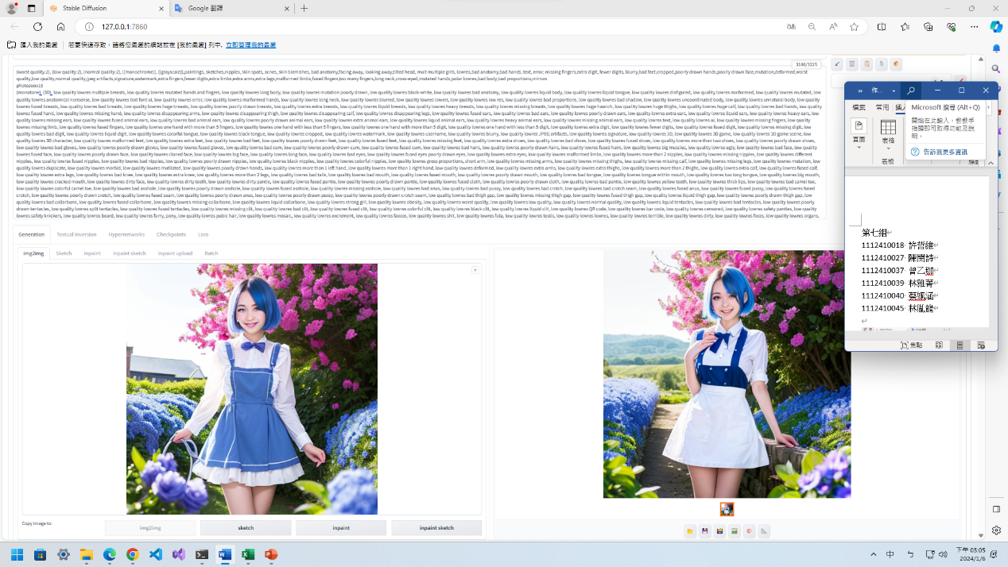

正面:

masterpiece, best quality, ultra-detailed, illustration, epic lighting, cinematic composition, colorful, anime, 2d, (finely detailed beautiful eyes: 1.2), 1girl, rem_\(re:zero\), cute, medium breasts, blue hair, short hair, (hair over one eye:1.3), blue eyes, roswaal_mansion_maid_uniform, apron, white thighhighs, standing, smile, closed mouth, cowboy shot, fantasy, summer, blue flowers, garden, blue roses,

sunlight, peaceful, serenity, (8k:1.1) <lora:ReZeroRem_v10:0.7> <lora:koreanDollLikenessL:0.3> ,crossed arms

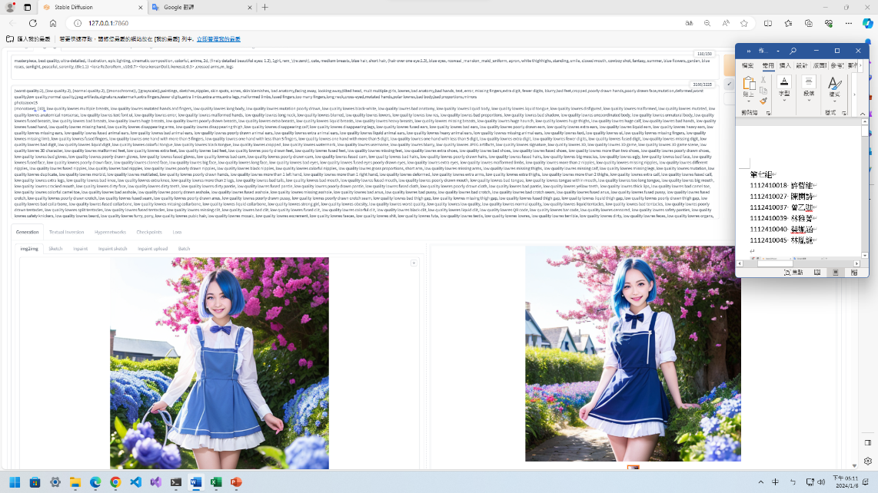

正面:

masterpiece, best quality, ultra-detailed, illustration, epic lighting, cinematic composition, colorful, anime, 2d, (finely detailed beautiful eyes: 1.2), 1girl, rem_\(re:zero\), cute, medium breasts, blue hair, short hair, (hair over one eye:1.3), blue eyes, roswaal_mansion_maid_uniform, apron, white thighhighs, standing, smile, closed mouth, cowboy shot, fantasy, summer, blue flowers, garden, blue roses, sunlight, peaceful, serenity, (8k:1.1) <lora:ReZeroRem_v10:0.7> <lora:koreanDollLikenessL:0.3> ,crossed arms,m_legs

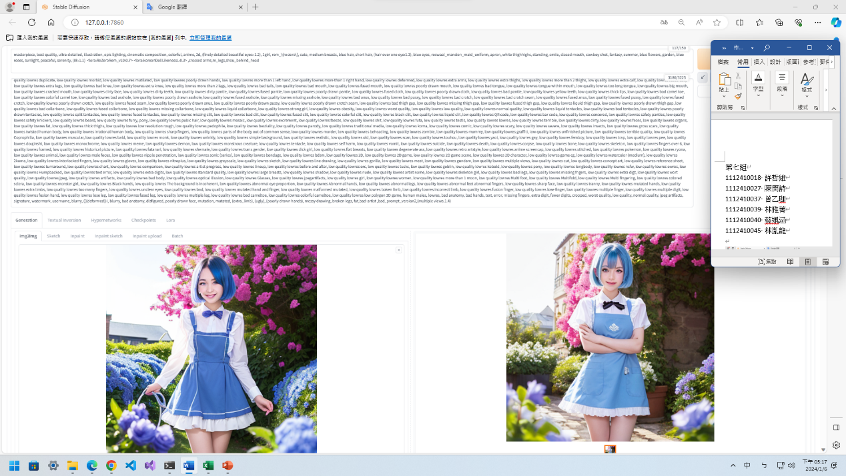

正面: masterpiece, best quality, ultra-detailed, illustration, epic lighting, cinematic composition, colorful, anime, 2d, (finely detailed beautiful eyes: 1.2), 1girl, rem_\(re:zero\), cute, medium breasts, blue hair, short hair, (hair over one eye:1.3), blue eyes, roswaal_mansion_maid_uniform, apron, white thighhighs, standing, smile, closed mouth, cowboy shot, fantasy, summer, blue flowers, garden, blue roses, sunlight, peaceful, serenity, (8k:1.1) <lora:ReZeroRem_v10:0.7> <lora:koreanDollLikenessL:0.3> ,crossed arms,m_legs,shou_behind_head

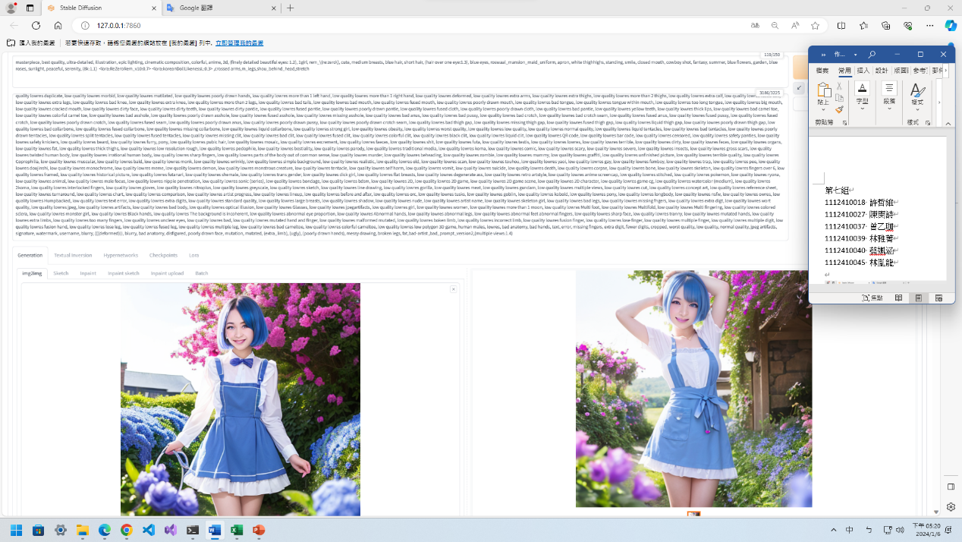

正面: masterpiece, best quality, ultra-detailed, illustration, epic lighting, cinematic composition, colorful, anime, 2d, (finely detailed beautiful eyes: 1.2), 1girl, rem_\(re:zero\), cute, medium breasts, blue hair, short hair, (hair over one eye:1.3), blue eyes, roswaal_mansion_maid_uniform, apron, white thighhighs, standing, smile, closed mouth, cowboy shot, fantasy, summer, blue flowers, garden, blue roses, sunlight, peaceful, serenity, (8k:1.1) <lora:ReZeroRem_v10:0.7> <lora:koreanDollLikenessL:0.3> ,crossed arms,m_legs,shou_behind_head,stretch

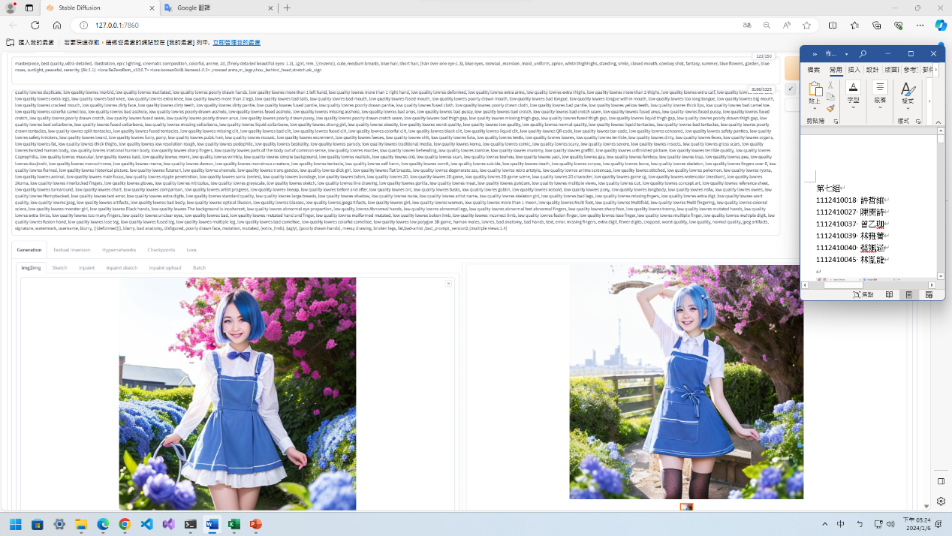

正面: masterpiece, best quality, ultra-detailed, illustration, epic lighting, cinematic composition, colorful, anime, 2d, (finely detailed beautiful eyes: 1.2), 1girl, rem_\(re:zero\), cute, medium breasts, blue hair, short hair, (hair over one eye:1.3), blue eyes, roswaal_mansion_maid_uniform, apron, white thighhighs, standing, smile, closed mouth, cowboy shot, fantasy, summer, blue flowers, garden, blue roses, sunlight, peaceful, serenity, (8k:1.1) <lora:ReZeroRem_v10:0.7> <lora:koreanDollLikenessL:0.3> ,crossed arms,m_legs,shou_behind_head,stretch,ok_sign